Math model

Problem: there is a coordinate grid of points of data, they need to be filtered to a specific, curved area.

Solution:

* How is the area determined?
  + Within a grid, you are given a specific point (A) on that grid & an angle from that point (determined in relation to the grid)
  + You are also given a target point (B) within the grid
  + Draw 2 circles of differing, specific radii from point (A)
  + Mark an area bounded by 45 degrees from either side of the given angle
  + Evaluate each point on the grid to see if it falls within the area bounded by the 2 circles and the 90-degree section

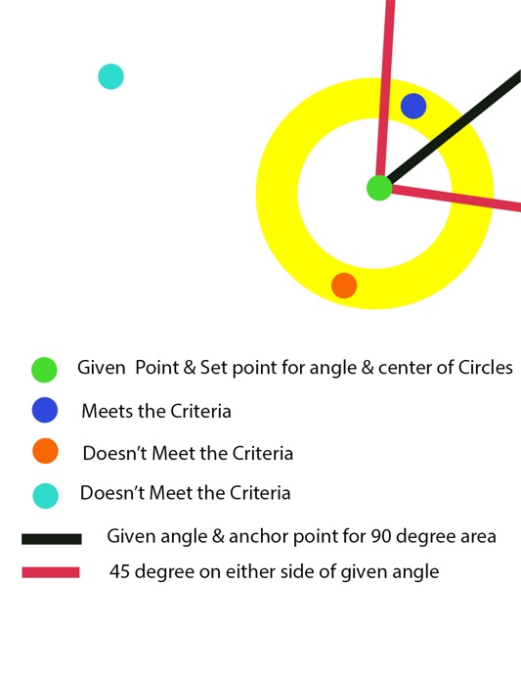

Math:

Each point is evaluated by generating the point values and comparing them within the bounds of the R and θ values

$$R_{internal}=17$$

$$R_{external}=25$$

$$θ=(α±45)×{(\frac{180}{π})}^{-1}$$

$$R_{point}=\frac{1}{{\left(x_{grid}-x_{shovel}\right)}^{2}+{\left(y_{grid}-y_{shovel}\right)}^{2}}$$

$$θ_{point}=\tan^{-1}\left(\frac{y_{grid}-y_{shovel}}{x_{grid}-x_{shovel}}\right)$$

Actual results:

* Here is the pertinent code?

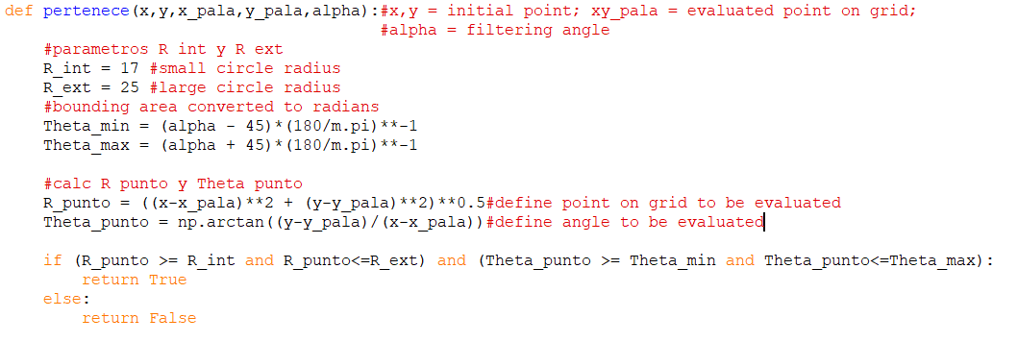

This function is run for each point in a list

Problematic results, and main question –

As visible by the graph, the current approach taken in the code causes 2 mirrored areas (1 correct, 1 false) to be created. The false area meets the criteria and can deliver a false positive. My question is, mathematically, why is this second area being created? And how could I address it? I believe it has something to do with mirrored angles across a plane. Although, I am not sure what I can do to solve it.

I hope this all makes sense, and I was wondering if you have any insight or guidance?